

DISSERTATION
On
“Virtual Screening and ADMET-Based Profiling of Small Molecule Modulators for Spinal Muscular Atrophy via SMN2 Splicing Enhancement.”

Dissertation Submitted to

Hon. Director, MGM University

Institute of Bioscience and Technology, Chh.Sambhajinagar

in partial fulfillment of the requirement for the degree of

BACHELOR OF SCIENCE IN BIOINFORMATICS

Submitted by
Ankita Chandrasekhar Bhosale
Bhumi Sunil Waykos

Reg. No. MMBBI232403,
MMBBI232401
Course No.: MBM42MMJ501

Course Title: Mini Project

Project Guide
Ms. Arpita Kharat
(Research Assistant)
Department of Bioinformatics
MGMU, IBT, Chh.Sambhajinagar

2025-26
1
DECLARATION BY THE CANDIDATE
We hereby declare that the thesis entitled, “Virtual Screening and ADMET-Based Profiling of Small Molecule Modulators for Spinal Muscular Atrophy via SMN2 Splicing Enhancement.” submitted by us is based on the actual work carried out by us under the guidance and supervision of Ms. Arpita Kharat The extent of information derived from the existing literature have been duly cited and referenced. The existing research work or its any part is not submitted anywhere else for the award of any degree or diploma.
We also hereby declare that no sentence, equation, diagram, table, paragraph or section has been copied verbatim from previous work unless it is cited and duly referenced. There is no plagiarism; the work presented is original and own work of the researcher. No ideas, process, results or words of others have been presented as researcher's own work.

Place: MGMU-IBT Chh.Sambhajinagar

Date:

Signature of the Candidate

Ankita Chandrashkhar Bhosale
Bhumi Sunil Wakyos
Reg No: MUBBI232403,
MUBBI232401



Institute of Biosciences and Technology Chh.Sambhajinagar
CERTIFICATE – I
This is to certify that the Mini project entitled, “Virtual Screening and ADMET-Based Profiling of Small Molecule Modulators for Spinal Muscular Atrophy via SMN2 Splicing Enhancement.” “Submitted by Ankita Chandrashkher Bhosale (MUBBI232403) and Bhumi Sunil Wakyos (MUBBI232401) in partial fulfilment of the requirements for the award of the degree of BACHELOR OF SCIENCE (Hons.) in the subject of Bioinformatics for the academic year 2025-26 submitted to the MGM University, IBT, Chh.Sambhajinagar. This is a record of bonafide research work carried out by us. The dissertation or its any part has not previously formed the basis for the award of any degree, diploma or other similar title.

Place: MGMU-IBT Chh.Sambhajinagar.
Date:

Signature of the Candidate

Ankita Chandrashkhar Bhosale
Bhumi Sunil Wakyos

Reg. No.: MUBBI232403
MUBBI232401


Institute of Biosciences and Technology

Chh.Sambhajinagar

CERTIFICATE – II

This is to certify that the Mini project entitled, “Virtual Screening and ADMET-Based Profiling of Small Molecule Modulators for Spinal Muscular Atrophy via SMN2 Splicing Enhancement.” submitted by in partial fulfilment of the requirements for the award of the degree of BACHELOR OF SCIENCE (Hons.) in the subject of Bioinformatics to the MGM University IBT, Chht.Sambhajinagar has been approved by the Research Advisory Committee after viva voce examination of the student in collaboration with the External Examiner.

Signature

External Examiner

Signature

Research Guide
Ms. Arpita Kharat

Signature

Project Incharge

Signature

HOI

PLAGIARISM CLEARANCE CERTIFICATE

This is to certify that thesis entitled “Virtual Screening and ADMET-Based Profiling of Small Molecule Modulators for Spinal Muscular Atrophy via SMN2 Splicing Enhancement.” submitted by Ankita Chandrashkher Bhosale (BBI232403) and Bhumi Sunil Wakyos (MUBBI232401) has been properly examined by plagiarism checker software. The percentage of similarities found in the thesis is 6%.
No sentence, equation, diagram, table, paragraph or section has been copied verbatim from previous work unless it is duly cited and referenced. The work presented is original and own work of the researcher (i.e. there is no plagiarism). No ideas, process, result or words of others have been presented as researcher's own work.

Signature

Ankita Chandrashkher Bhosale

Bhumi Sunil Wakyos

Signature

Ms. Arpita Kharat

ACKNOWLEDGEMENT

The success of any project depends largely on the team work and also encouragement and guidelines of many others. We take this opportunity to express our gratitude to the people who have been instrumental in the successful completion of this project.
To start with, We would like to express my sincere gratitude to my Project Guide Ms. Arpita Kharat, Research Assistant, Department of Bioinformatics; who offered us guidance and support all along the completion of the project. I gratefully place on record my gratitude towards Ms. Arpita Kharat
We are thankful to Dr. S.N. Harke, HOI for supporting us during the whole curriculum. Thanks are also due to other members of Team IBT, who inspired me during this unforgettable journey. We express our sincere thanks to all Academic and Office Staff of this College for their kind helps during training work.

Place: IBT MGMU.
Date:

Signature of the candidate
Ankita Chandrashkher Bhosale
Bhumi Sunil Wakyos
Reg. No. MUBBI232403
MUBBI232401

ABBREVIATIONS

• SMA: Spinal muscular atrophy
• SMN1: Survival motor neuron 1
• SMN2: Survival motor neuron 2
• E7I: Exon 7 inclusion
• VS: Virtual screening
• MDock: Molecular docking
• ADMET: Absorption, distribution, metabolism, excretion, and toxicity
• MD: Molecular dynamics simulation
• SRs: Splicing regulators
•DLMs: Drug-like molecules
• PK: Pharmacokinetics
• SBDD: Structure-based drug design

CONTENT

Sr.  No. | Title / Particulars | Page  No.
01 | Declaration by the Candidate | i
02 | Certificate – I | ii
03 | Certificate – II | iii
04 | Plagiarism Clearance Certificate | iv
05 | First Page of Plagiarism Report | v
06 | Acknowledgement | vi
07 | Abbreviations Used (if any) | vii
08 | Contents | viii
09 | Thesis /Dissertation Abstract | 1
10 | Chapter - I : Introduction and Objectives | 2-5
11 | Chapter - II : Review of Literature | 6-7
12 | Chapter - III : Materials and Methods | 8-9
13 | Chapter - IV : Results | 9-17
14 | Chapter - V : Discussion | 18
15 | Chapter - VI : Summary and Conclusions | 19
16 | Future Line Work | 20
17 | Reference | 21-22

ABSTRACT

Title of the thesis : “Virtual Screening and ADMET-Based Profiling of Small Molecule Modulators for Spinal Muscular Atrophy via SMN2 Splicing Enhancement.”
Full name of the candidates : Ankita Chandrashkher Bhosale
Bhumi Sunil Wakyos
Full Name of the Research Guide : Ms. Arpita Kharat
Department / College / University : MGM University, Institute of Biosciences and Technology
Degree to be awarded : Bachelor Of Science (Hons) Bioinformatics

Spinal muscular atrophy (SMA) is a severe autosomal recessive neuromuscular disorder and the most common genetic cause of mortality in infants. It results from homozygous deletion or functional loss of the survival motor neuron 1 (SMN1) gene, leading to reduced levels of SMN protein essential for motor neuron survival. Although humans possess a paralogous gene, SMN2, a single nucleotide substitution causes frequent exon 7 skipping, thereby producing unstable and non-functional SMN protein. Enhancing exon 7 inclusion in SMN2 transcripts represents a promising therapeutic strategy. In this study, a comprehensive structure-based virtual drug discovery pipeline was employed to identify novel small molecules with the potential to modulate SMN2 splicing and increase functional SMN protein expression. Large compound libraries were virtually screened, followed by molecular docking to predict binding interactions with splicing regulators. Top candidates were further refined through ADMET profiling to assess pharmacokinetic and toxicity properties, and molecular dynamics (MD) simulations were performed to validate binding stability and complex conformational behavior. In silicon analyses identify potential lead molecules with robust drug-like features, favorable safety profiles, and stable interactions with target proteins. The findings provide a rational foundation for future experimental validation and preclinical studies, with the ultimate goal of developing novel, cost-effective, and orally available small-molecule therapeutics for SMA.
Keywords: Spinal muscular atrophy (SMA), SMN1 gene, SMN2 splicing, exon 7 inclusion, virtual screening, molecular docking, ADMET profiling, molecular dynamics (MD) simulation, splicing regulators, drug-like molecules, pharmacokinetics, toxicity prediction, structure-based drug design, small-molecule therapeutics.

CHAPTER- I

INTRODUCTION

Spinal muscular atrophy (SMA) is a rare, inherited neuromuscular disorder characterized by progressive degeneration of motor neurons in the anterior horn of the spinal cord, leading to muscle weakness and atrophy. It is recognized as the leading genetic cause of death in infants and toddlers. The historical origins of SMA date back to the late 19th century, when Guido Werdnig (1891) and Johann Hoffmann (1893) independently described cases presenting with progressive muscle weakness in children from affected families, marking the first clinical recognition of the disease. Modern genetic studies identified the primary cause of SMA as homozygous deletion or loss-of-function mutations in the survival motor neuron 1 (SMN1) gene, located on chromosome 5q13 (Lefebvre et al., 1995). The SMN protein, encoded by SMN1, plays a crucial role in the assembly of the spliceosomal small nuclear ribonucleoproteins (snRNPs) required for pre-mRNA splicing in all cells, but its depletion is particularly harmful to motor neurons.
In humans, a second gene—survival motor neuron 2 (SMN2)—is almost identical to SMN1 but contains a single nucleotide variation in exon 7, resulting in its exclusion from most mature transcripts. This leads to the production of a truncated, unstable SMN protein that is rapidly degraded (Lorson et al., 1999). Although SMN2 cannot fully compensate for SMN1 loss, it produces small amounts of functional SMN protein, which partly modulates disease severity. The copy number of SMN2 is a major genetic determinant of the clinical spectrum of SMA, which ranges from the most severe type 1 (infantile onset, never able to sit) to milder types 2 and 3 (later onset, ability to sit or walk with eventual decline) and the rare adult-onset type 4. Without intervention, type 1 SMA infants typically die within the first two years due to respiratory failure.
The recent advent of disease-modifying therapies has shifted the treatment paradigm for SMA. Nusinersen, approved in December 2016, is an antisense oligonucleotide (ASO) that promotes exon 7 inclusion in SMN2 transcripts, increasing the amount of functional SMN protein. Other approaches, including gene replacement therapy (onasemnogene, abeparvovec) and small molecules such as risdiplam, highlight the growing focus on targeting the SMN2 splicing mechanism and restoring SMN protein levels.

Computational Drug Discovery in SMA
The pursuit of new therapeutic agents for SMA is enhanced by computational methods such as virtual screening and molecular docking. Virtual screening enables researchers to evaluate large chemical libraries swiftly, ranking compounds based on predicted binding affinity to target biomolecules. This significantly lowers both costs and timelines compared to traditional high-throughput experimental screening (Lionta et al., 2014). In the context of SMA, targets include proteins and regulatory complexes involved in SMN2 splicing—agents capable of modulating splicing or stabilizing SMN protein are of particular interest.
Following virtual screening, top-ranked molecules undergo molecular docking simulations to predict how they interact with specific binding sites on the target protein, akin to fitting a key into a lock. This facilitates detailed examination of ligand–protein interactions, hydrogen bonding, hydrophobic contributions, and conformational stability, ultimately prioritizing compounds for in vitro and in vivo validation (Meng et al., 2011).

ADMET Profiling
Another critical step in computational SMA drug discovery is ADMET analysis (Absorption, Distribution, Metabolism, Excretion, and Toxicity). Early prediction of ADMET properties helps eliminate candidates likely to fail due to poor pharmacokinetics or unacceptable toxicity, thereby streamlining the preclinical pipeline. This integration of in silico screening, docking, and ADMET evaluation creates an efficient workflow for discovering and optimizing SMA therapeutics.

Rationale for Research
Given SMA’s devastating impact, especially in the pediatric population, and the limited range of approved therapeutics, ongoing research aims to expand the arsenal of disease-modifying and symptom-alleviating agents. Computational approaches not only accelerate the identification of novel compounds but also open avenues for repurposing existing drugs with known safety profiles. The dual contribution of SMN1 and SMN2 genetics offers a clear molecular target for rational drug design, positioning SMA as a model disease for precision medicine strategies integrating genomics, structural biology, and computational chemistry.

Virtual screening (VS) is a computational approach used in drug discovery to identify potential drug candidates from large libraries of small molecules that may bind to a biological target such as a receptor or enzyme. It allows researchers to efficiently narrow down billions of possible compounds to a smaller set of promising hits for experimental validation, significantly reducing both cost and time compared to wet-lab high-throughput screening.

OBJECTIVES

- Understand the structural and functional roles of SMN1 and SMN2 in Spinal Muscular Atrophy (SMA).
- Identify small molecules that enhance SMN protein expression or stability from SMN2.
- Perform virtual screening and molecular docking of compounds against targets involved in SMN2 regulation.
- Analyze binding affinity and interactions of lead compounds with targets.
- Predict ADMET properties of top compounds to evaluate drug-likeness and safety.
- Select potential lead molecules for future experimental testing to develop SMA therapeutics

CHAPTER- II

REVIEW OF LITERATURE

2.1 Genetic Cause of SMA (Lorson et al, 1999; Lunn & Wang, 2008)
Lorson et al. (1999) and Lunn & Wang (2008) reported that Spinal Muscular Atrophy (SMA) is caused by the deletion or mutation of the SMN1 gene, which leads to reduced levels of the SMN protein, essential for the survival of motor neurons. Although humans also carry a similar gene called SMN2, it only produces a small amount of functional SMN protein due to a splicing defect in exon 7. The number of SMN2 gene copies present in individuals plays an important role in determining the severity of the disease.

2.2 Types and Symptoms of SMA (Lunn & Wang, 2008)
Lunn & Wang. (2008) researched that SMA is classified into different types. Type 1 is the most severe and begins in infancy, often leading to early death without treatment. Type 2 and 3 are less severe but still cause muscle weakness. Children with Type 2 may sit but cannot walk, while those with Type 3 can walk at first but may lose this ability over time.

2.3 Nusinersen – A New Hope for SMA Patients (Hua et al, 2010)
Hua et al. (2010) discovered that nusinersen, an antisense oligonucleotide drug approved in 2016, is the first disease-modifying treatment for SMA. This drug works by correcting the splicing of the SMN2 gene, enabling it to produce more full-length and functional SMN protein. Nusinersen has shown positive results in improving motor function and increasing survival rates among SMA patients.

2.4 Use of Virtual Screening in Drug Discovery (Lionta et al, 2014)
Lionta et al. (2014) stated that virtual screening is a computer-based technique used to identify potential drug candidates by screening large libraries of small molecules. In SMA research, virtual screening helps to quickly find molecules that may bind to specific targets, such as splicing regulators, which are involved in SMN2 exon 7 inclusion. This method is cost-effective and reduces the time required for initial drug discovery.

2.5 Molecular Docking and ADMET Analysis (Meng et al, 2011)

Meng et al. (2011) explained that molecular docking is used to predict how small drug-like molecules interact with larger biological molecules such as proteins or RNA. This technique helps researchers visualize how well a molecule fits into the target site. ADMET analysis, on the other hand, evaluates the pharmacological properties of these molecules, including absorption, metabolism, and toxicity. Together, these tools play a crucial role in finding effective and safe therapeutic candidates for SMA.

CHAPTER III

MATERIALS AND METHODS

MATERIALS:
- PDB: Protein Data Bank
- Open Babel
- SWISS-MODEL
- AutoDock Vina
- Cactus
- AMBER
- PyMOL
- pkCSM

METHODS:

Target Selection

The SMN2 (Survival Motor Neuron 2) protein, which plays a key role in the pathology of Spinal Muscular Atrophy (SMA), was selected as the target protein. The 3D structure of SMN2 was retrieved from the Protein Data Bank (PDB) in .pdb format for molecular docking analysis.

2. Protein Preparation
The downloaded SMN2 structure was prepared by removing water molecules, heteroatoms, and non-essential ligands using PyMOL
. Hydrogen atoms were added, and missing residues were corrected to obtain a refined protein structure suitable for docking. The prepared protein was saved in .pdbqt format using AutoDock Tools.

3. Ligand Preparation
A library of small molecules was collected from the PubChem database, including natural compounds such as quercetin and other phytochemicals with potential neuroprotective effects.
All ligands were:
- Downloaded in .sdf format,
- Energy-minimized,
- Converted to .pdbqt format using OpenBabel or AutoDock Tools.

4. Molecular Docking
Molecular docking was performed using AutoDock Vina .
The active site of SMN2 was defined by selecting grid box coordinates that covered the protein’s binding pocket.
Each ligand was docked into the active site, and binding affinities (in kcal/mol) were obtained.
Among all screened ligands, quercetin showed a binding energy of −7.0 kcal/mol, indicating a moderately strong and stable interaction with the SMN2 active site.

5. Interaction Analysis
The top-ranked docking poses were visualized PyMOLto analyze:
- Hydrogen bonding and hydrophobic interactions,
- The key amino acid residues involved in ligand binding.
For quercetin, interactions were observed with several active-site residues of SMN2, confirming its potential to bind and stabilize the protein.

6. ADMET Analysis
The shortlisted ligands were subjected to ADMET profiling using SwissADME and pkCSM web tools.
The properties such as drug-likeness, solubility, absorption, and toxicity were predicted.
Quercetin satisfied most drug-likeness criteria (Lipinski’s Rule of Five), suggesting favorable pharmacokinetic behavior.

7. Molecular Dynamics
To validate the docking results, molecular dynamics (MD) simulations were performed using AMBER for the SMN2–quercetin complex.
Parameters such as RMSD, RMSF, were analyzed to evaluate the stability of the complex over time.

CHAPTER- IV

RESULTS

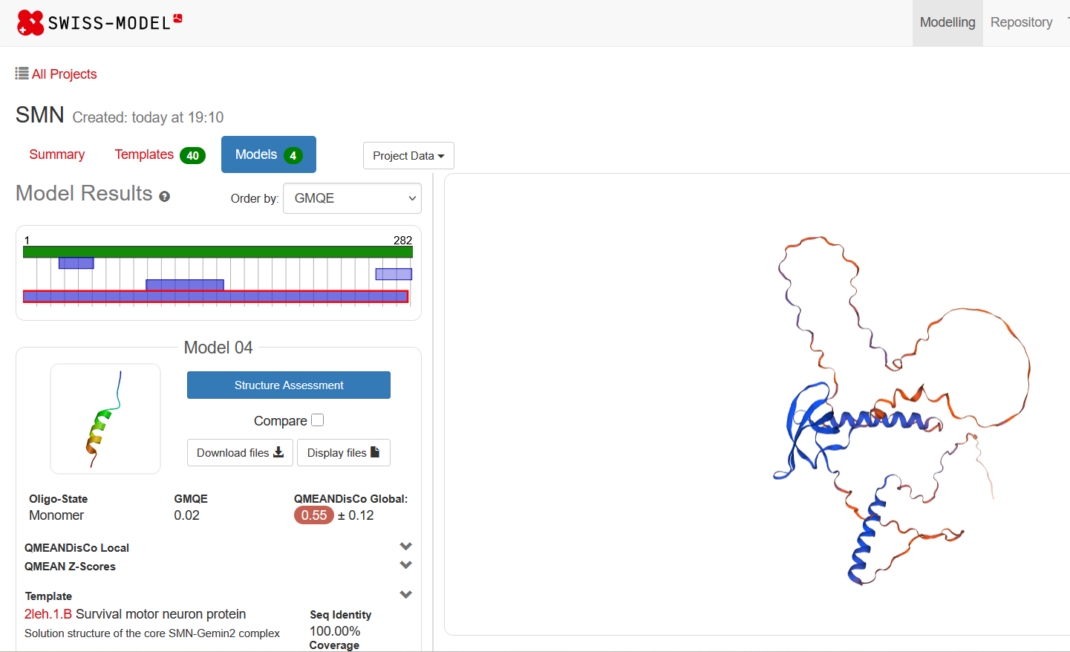
Predicted 3D structure of SMN (Survival Motor Neuron) protein generated using Swiss-Model. The model is based on the template 2leh.1.B, representing the core SMN-Gemin2 complex. The structure highlights the protein's secondary structural elements including alpha-helices (blue), loops (orange/red), and overall folding. Selected the plot by seeing the Ramachandran Plot and seq identity
Fig 1 : Prediction of SMN protein using SwissMod

Compound | Best Binding Energy (kcal/mol) | Interpretation
Quercetin | −7.32 | Strongest binding — most favorable interaction
D-Cycloserine | −6.44 | Good binding
Curcumin | −6.50 | Good binding
Trichostatin | −6.01 | Moderate binding
Salbutamol | −6.02 | Moderate binding
Dexamethasone | −6.05 | Moderate binding
Branaplam | −6.20 | Moderate binding
Risdiplam | −4.88 | Known SMA drug; weaker than Quercetin
Celecoxib | −4.54 | Weak binding
Valproic acid | −2.99 | Very weak binding
Resveratrol | +15.78 | Unfavorable / unstable binding (positive energy)
Top Ligand with the Best Docking Binding Energy Against SMN Protein

Taken together, these docking results enable the prioritization of top candidates, such as quercetin, curcumin,
and d-cycloserine, for subsequent molecular dynamics simulations and pharmacokinetic assessments. The strong binding affinities observed support their potential as lead compounds targeting the SMN protein, paving the way for further computational and experimental evaluations in the future.

Table 1:Binding energy between different ligands with targeted SMN protein

SMILES and ID Of Quercetin
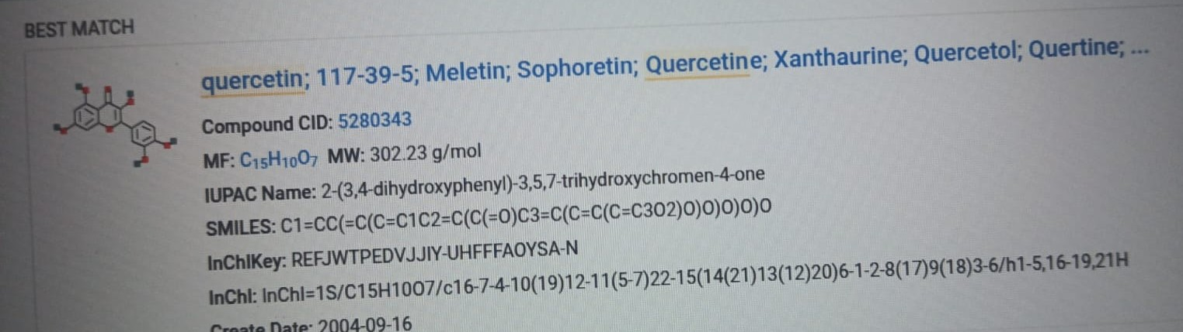

Fig 4.2 Smiles and id number of quercetin ligand from Pubchem

Add a text box below the image with details such as:
- "Quercetin (PubChem CID: 5280343)"
- "SMILES: C1=CC(=C(C=C1C2=C(C(=O)C3=C(C=C(C=C3O2)O)O)O)O)O"

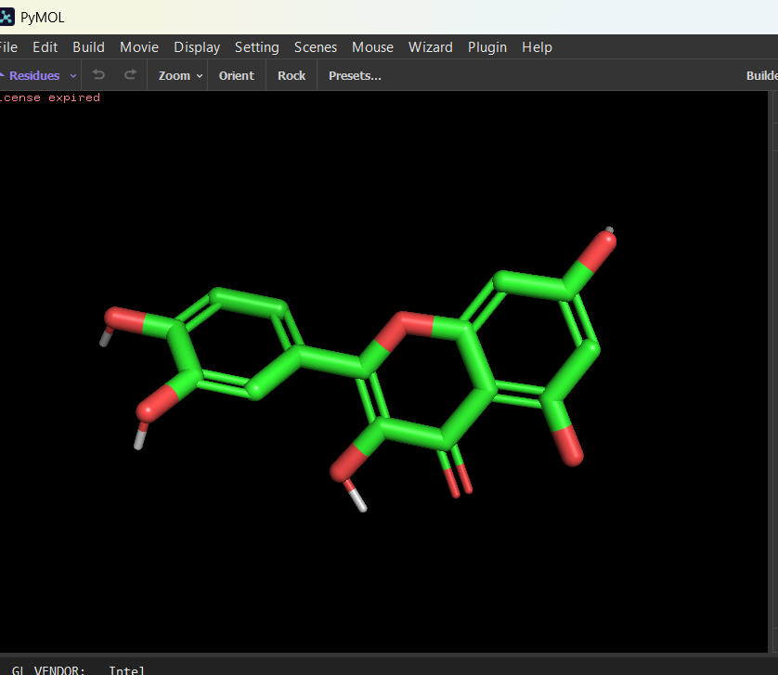

Fig 4.3 : Visualization of ligand (Quercetin) using PyMOL
Three-dimensional structure of quercetin visualized in PyMOL. Quercetin is a natural flavonoid (PubChem CID: 5280343) known for its antioxidant and potential neuroprotective properties. Its chemical structure is characterized by multiple hydroxyl groups attached to a polycyclic aromatic backbone, which can contribute to hydrogen bonding with protein targets.
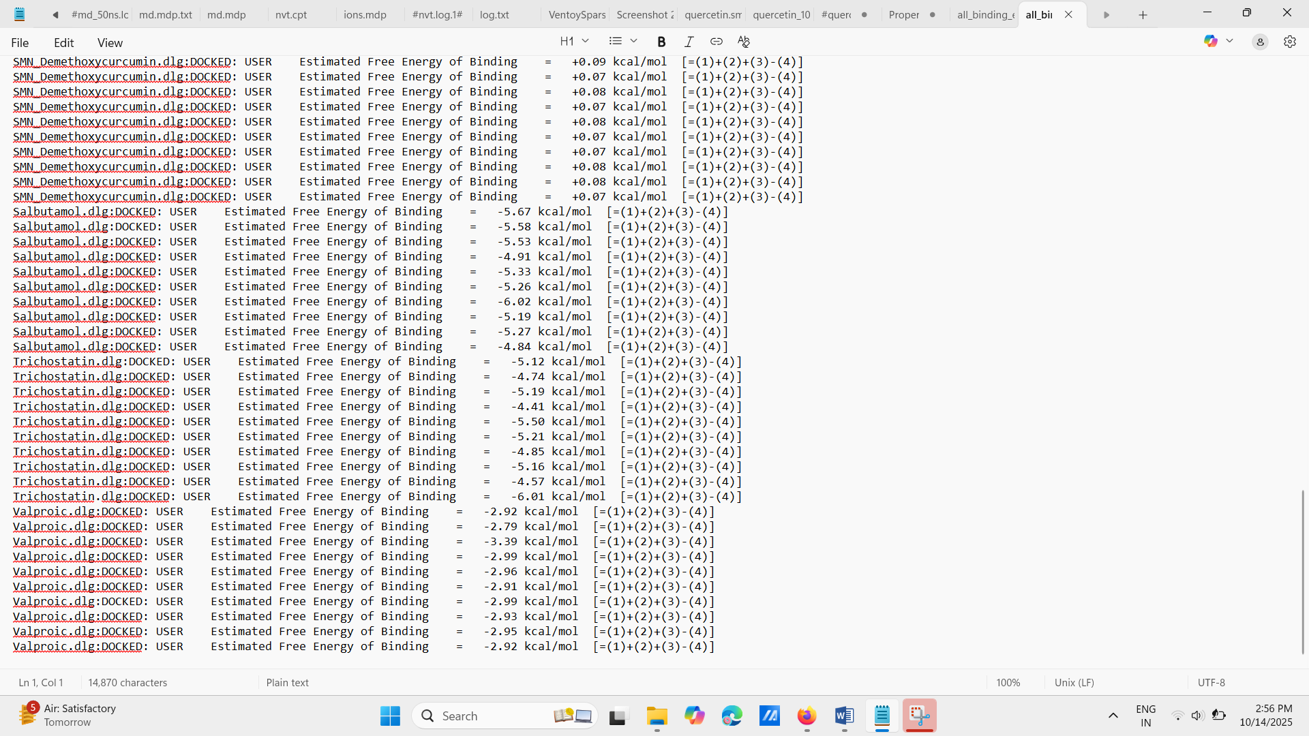
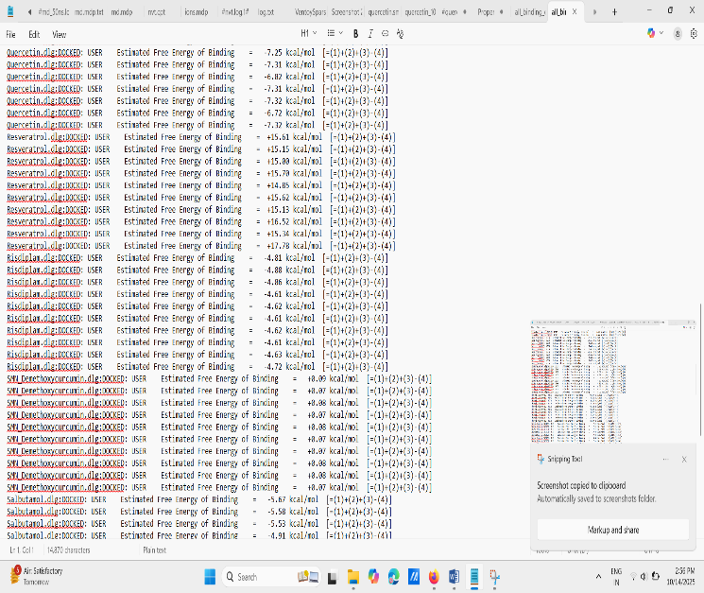
Identification of High-Affinity Ligands Through Virtual Screening Targeting SMN Protein
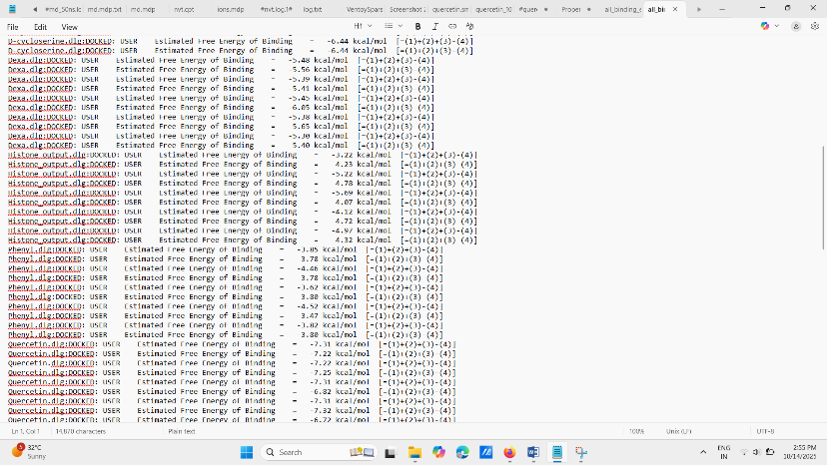
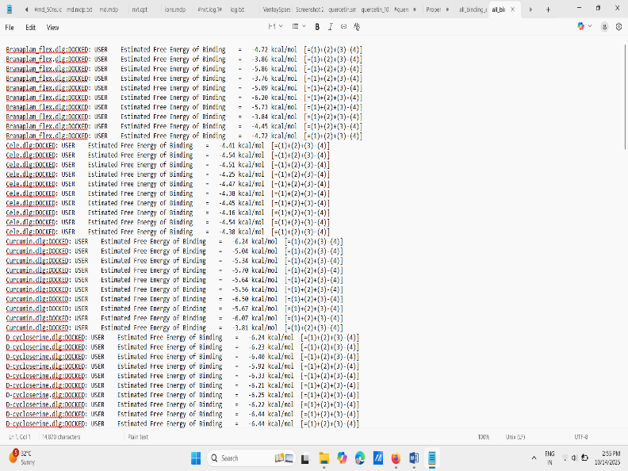

Fig 4.4 Virtual screening of all ligands where studied in molecular docking

Virtual screening of small molecules against the SMN protein identified quercetin as a top candidate due to its high binding affinity and favorable interactions with key residues. Quercetin was then selected for molecular dynamics (MD) simulation to evaluate the stability and dynamic behavior of the ligand–protein complex under physiological conditions.

MD Simulation :

Molecular dynamics simulation box showing the SMN protein–ligand complex solvated in a cubic water box. The numerous red and white sticks represent water molecules forming a solvation shell around the biomolecules. Green spheres represent counter ions added to neutralize the system and mimic physiological ionic strength. This environment replicates realistic aqueous conditions for studying protein–ligand interactions during MD simulations.
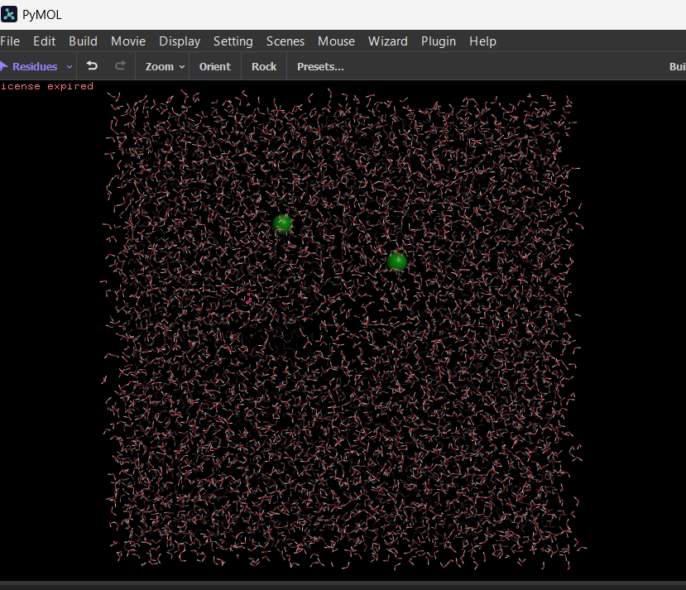

Fig no.4.5: Final Result of MD simulation

.
Molecular dynamics (MD) simulations allow detailed study of biomolecules like proteins and ligands at an atomic level under realistic physiological conditions. In the simulation, the protein–ligand complex is placed inside a cubic box that acts as a boundary, using periodic boundary conditions to mimic an infinite environment and avoid edge effects. The complex is surrounded by explicit water molecules forming a solvation shell that stabilizes the structures via hydrogen bonding and influences binding through electrostatic and hydrophobic interactions. Counter ions such as sodium or chloride are added to neutralize the system charge and replicate physiological salt concentrations, preventing unrealistic electrostatic effects. This setup creates a natural aqueous ionic environment, enabling the simulation to capture molecular interactions, conformational changes, and binding events over time. By solving Newton’s equations of motion with molecular force fields, the simulation tracks atomic movements continuously, providing valuable insights into stability, flexibility, and complex formation crucial for understanding biological function and aiding drug design. This environment closely mimics conditions in living cells, helping researchers predict drug binding and protein behavior with atomic-level precision.

Molecular Dynamics Simulation Stability and Flexibility Analysis

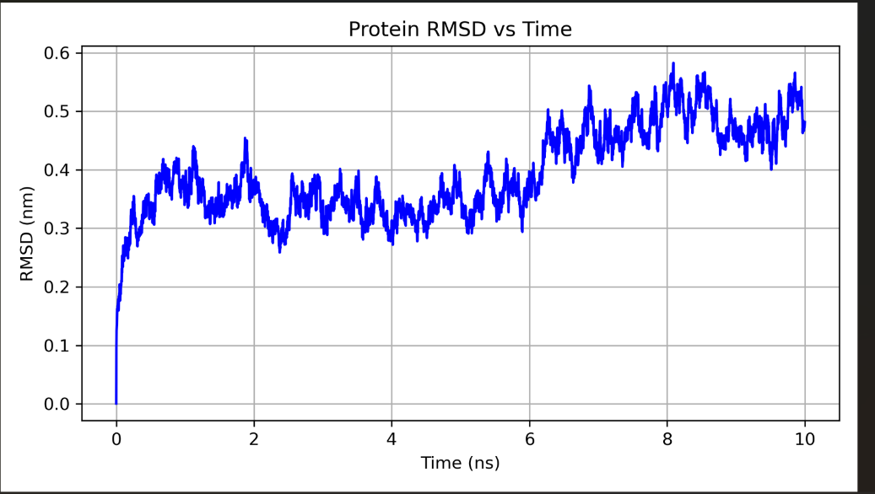

Fig4.6:Plot of Protein RMSD vs Time

The RMSD graph illustrates the structural stability of the system throughout the simulation, with fluctuations stabilizing after the initial equilibration phase, indicating convergence to a stable conformation.

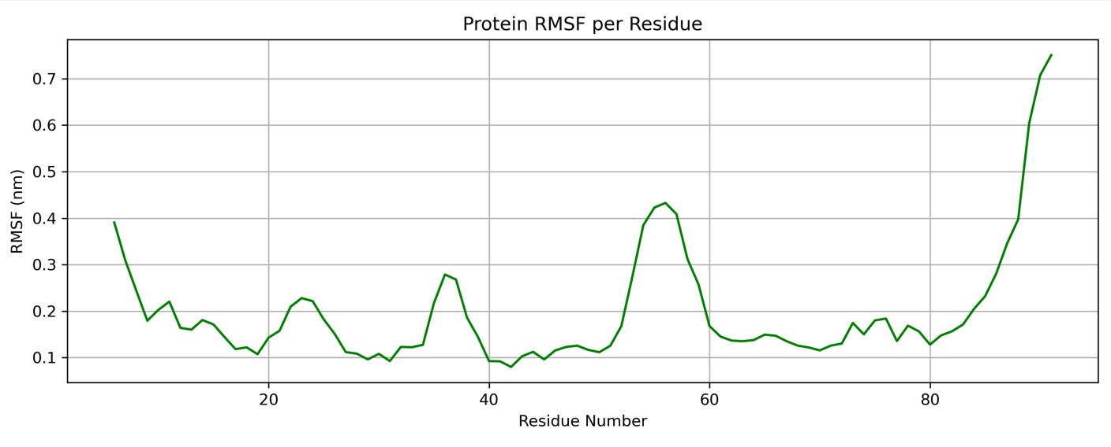

Fig 4.7:Plot of Protein RMSF per Residue

The RMSF plot highlights the flexibility of individual residues, with peaks corresponding to regions of higher mobility such as loops or binding sites, providing insights into dynamic regions relevant to function or ligand interaction.

Absorption, Distribution, Metabolism, Excretion, and Toxicity (ADMET) Prediction

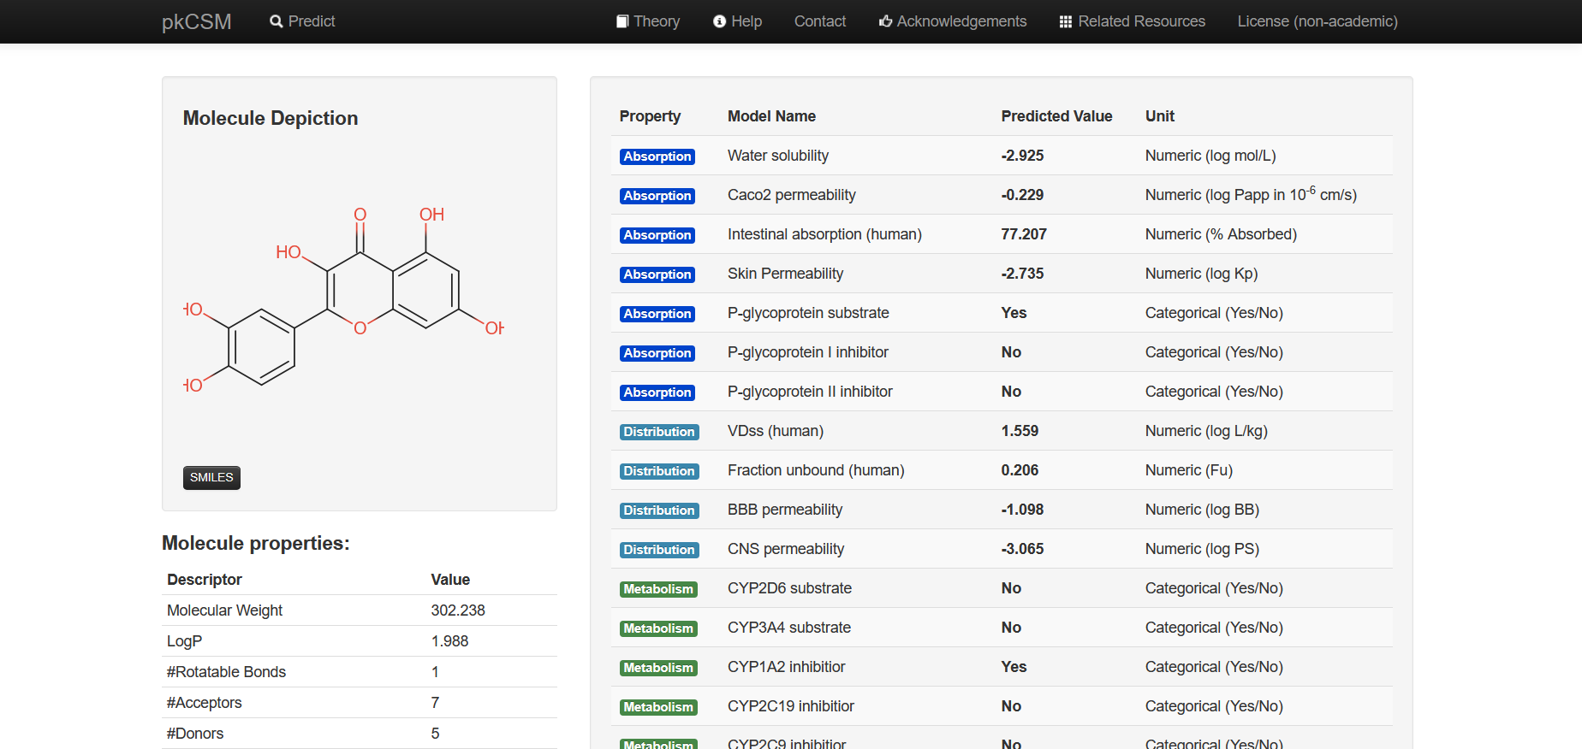
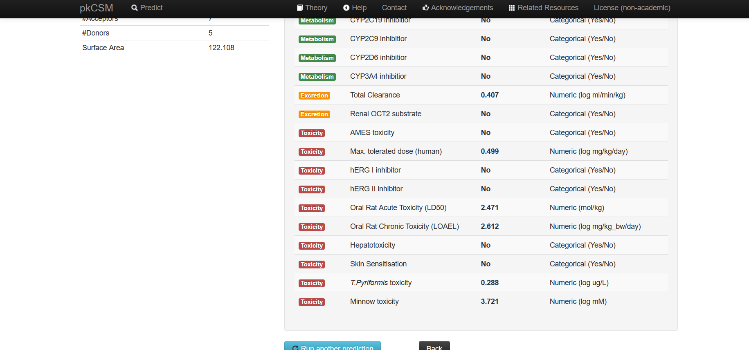

Fig 4.8:ADMET properties of ligand
The ADMET analysis predicts favorable pharmacokinetic and toxicity profiles for the compound, indicating good absorption, metabolism stability, and low toxicity risks, supporting its potential as a safe therapeutic candidate.

In Silico Drug-Likeness Evaluation of [Quercetin] through Lipinski’s Rule of Five

Property | Your Value | Rule of 5 Criteria | Within Rule?
Molecular Weight | 302.238 | ≤ 500 | Yes
LogP | 1.988 | ≤ 5 | Yes
Donors | 5 | ≤ 5 | Yes
Acceptors | 7 | ≤ 10 | Yes

Table no.:2 comparision of Lipinski’s Rule of Five

Lipinski’s Rule of Five is a widely used guideline in drug discovery that predicts whether a compound is likely to be orally bioavailable based on its molecular weight, lipophilicity (LogP), and the number of hydrogen bond donors and acceptors. Compounds that meet these criteria generally have better absorption and oral efficacy.

CHAPTER- V

DISSCUSION

Spinal Muscular Atrophy (SMA) is a severe neuromuscular disease primarily caused by deficiency of Survival Motor Neuron (SMN) protein due to mutations in the SMN1 gene. The paralogous SMN2 gene, though nearly identical, is inefficient in producing functional SMN protein due to aberrant splicing. This study aimed to identify small-molecule modulators capable of enhancing SMN2 splicing or stabilizing SMN protein through an in silico drug discovery pipeline involving virtual screening, molecular docking, molecular dynamics (MD) simulations, and ADMET profiling.

Virtual screening and molecular docking identified quercetin as the top candidate among a library of small molecules, exhibiting the strongest binding affinity with a docking energy of −7.32 kcal/mol against the SMN protein of tertiary structure. This suggested that quercetin can form stable interactions within the binding pocket, potentially influencing SMN protein function and stability. Key hydrogen bonding and hydrophobic interactions with active site residues support this binding stability.

Molecular dynamics simulations validated the docking results, revealing that the SMN-quercetin complex remained structurally stable over the simulation timeframe. The root mean square deviation (RMSD) analysis showed minimal fluctuations after initial equilibration, indicating the protein-ligand complex converged toward a stable conformation. Root mean square fluctuation (RMSF) plots further highlighted flexible regions likely involved in ligand interaction, offering insights into dynamic behavior relevant to function.

ADMET analysis predicted that quercetin possesses favorable drug-like properties. It complied fully with Lipinski's Rule of Five, indicating good oral bioavailability potential. Pharmacokinetic predictions showed favorable absorption, distribution, metabolism, excretion, and low toxicity risks, making quercetin a promising lead compound for further development. The combination of strong binding, dynamic stability, and favorable ADMET properties underscores quercetin's therapeutic potential as an SMN modulator in SMA treatment.

The integration of computational approaches significantly accelerates drug discovery by reducing experimental costs and time, while prioritizing compounds with high success probability. This study's findings provide a rational basis for advancing quercetin toward experimental validation, including biochemical assays to confirm its effect on SMN2 splicing and functional protein levels. Moreover, further optimization through medicinal chemistry could enhance its potency and pharmacological profile.

Conclusion

This project successfully applied a comprehensive computational pipeline to identify and characterize potential small molecule modulators for SMA targeting SMN protein. Quercetin emerged as the lead candidate exhibiting the highest binding affinity, supported by stable molecular dynamics simulations and a favorable ADMET profile. These in silico results suggest quercetin has promise as a therapeutic agent capable of modulating SMN protein function or SMN2 splicing to ameliorate SMA pathology.

The study highlights the power of combining virtual screening, molecular docking, MD simulation, and ADMET prediction for efficient early-stage drug discovery against complex genetic diseases like SMA. However, given the purely computational nature of this work, experimental validation and in vivo studies are essential next steps to confirm the biological efficacy, safety, and clinical potential of quercetin-based therapies.

In summary, this research provides a rational platform for future drug development efforts aimed at improving SMA treatment options, potentially benefitting patients through more accessible and cost-effective small molecule therapeutics.

CHAPTER-VI

SUMMARY AND CONCLUSION

Spinal muscular atrophy (SMA) stands as a critical genetic disorder with significant implications for infant and childhood mortality worldwide. The elucidation of its genetic basis—primarily the deletion or mutation of SMN1 and the modulatory role of SMN2—has revolutionized therapeutic development, enabling the rise of targeted interventions such as splicing modulators, gene therapy, and small molecules aimed at restoring functional SMN protein levels. While disease-modifying therapies like nusinersen, risdiplam, and onasemnogene abeparvovec represent major milestones, their high costs, delivery complexities, and limited worldwide access mean that many patients remain underserved. Moreover, these current approaches cannot fully address all disease manifestations, particularly in severe early-onset cases or in populations with restricted medical infrastructure.
Computational drug discovery methods, including virtual screening, molecular docking, and ADMET profiling, present a transformative opportunity to accelerate the identification of new therapeutic candidates for SMA. By enabling rapid and cost-efficient screening of vast chemical libraries and predicting molecular interactions with high precision, these techniques can identify promising compounds capable of modulating SMN2 splicing, improving protein stability, or targeting secondary pathways involved in disease progression. Importantly, the integration of computational approaches with experimental validation offers a synergistic framework for drug development that can drastically reduce attrition rates and time-to-market.
As advancements in computational biology, genomics, and structural modeling continue, there is a realistic prospect of developing accessible, effective, and globally scalable therapies. Such innovations would not only expand treatment options but also bridge gaps in availability for patients across varying socioeconomic backgrounds. Ultimately, harnessing the combined power of genetic understanding and computational efficiency could reframe SMA from a fatal pediatric condition to a manageable disorder, drastically improving survival rates, quality of life, and global healthcare equity.

FUTURE LINE OF WORK

This study aims to identify potential small molecule modulators that enhance SMN2 exon 7 splicing using a fully computational drug discovery approach It involves:
- Target preparation of splicing regulators.
- Virtual screening of compound libraries via molecular docking
- Molecular dynamics simulations to assess complex stability
- ADMET profiling to evaluate pharmacokinetic and toxicity properties
The study is purely computational and designed to prioritize drug-like compounds for future experimental validation in the treatment of Spinal Muscular Atrophy (SMA).

REFERENCES

Cherry, J. J., Rigo, F., Krainer, A. R., & Sattler, R. (2020). Small molecule enhancement of SMN protein production through modulation of SMN2 splicing. Neurotherapeutics, 17(2), 652–663. https://doi.org/10.1007/s13311-020-00833-3
Finkel, R. S., McDermott, M. P., Kaufmann, P., Darras, B. T., Chung, W. K., Sproule, D. M., ... & De Vivo, D. C. (2014). Observational study of spinal muscular atrophy type I and implications for clinical trials. Neurology, 83(9), 810–817. https://doi.org/10.1212/WNL.0000000000000741
Finkel, R. S., Mercuri, E., Darras, B. T., Connolly, A. M., Kuntz, N. L., Kirschner, J., ... & De Vivo, D. C. (2017). Nusinersen versus sham control in infantile-onset spinal muscular atrophy. The New England Journal of Medicine, 377(18), 1723–1732. https://doi.org/10.1056/NEJMoa1702752
Jarecki, J., Chen, X., Bernardino, A., & Stackhouse, T. (2005). Diverse small-molecule modulators of SMN2 splicing increase SMN protein expression in vitro and in vivo. The Journal of Clinical Investigation, 115(3), 881–890. https://doi.org/10.1172/JCI23487
Kolb, S. J., & Kissel, J. T. (2015). Spinal muscular atrophy. Neurologic Clinics, 33(4), 831–846. https://doi.org/10.1016/j.ncl.2015.07.004
Lefebvre, S., Bürglen, L., Reboullet, S., Clermont, O., Burlet, P., Viollet, L., ... & Melki, J. (1995). Identification and characterization of a spinal muscular atrophy–determining gene. Cell, 80(1), 155–165. https://doi.org/10.1016/0092-8674(95)90460-3
Lionta, E., Spyrou, G., Vassilatis, D. K., & Cournia, Z. (2014). Structure-based virtual screening for drug discovery: principles, applications and recent advances. Current Topics in Medicinal Chemistry, 14(16), 1923–1938. https://doi.org/10.2174/1568026614666140929124445
Lorson, C. L., Hahnen, E., Androphy, E. J., & Wirth, B. (1999). A single nucleotide in the SMN gene regulates splicing and is responsible for spinal muscular atrophy. Proceedings of the National Academy of Sciences, 96(11), 6307–6311. https://doi.org/10.1073/pnas.96.11.6307
Lunn, M. R., & Wang, C. H. (2008). Spinal muscular atrophy. The Lancet, 371(9630), 2120–2133. https://doi.org/10.1016/S0140-6736(08)60921-6
Meng, X. Y., Zhang, H. X., Mezei, M., & Cui, M. (2011). Molecular docking: a powerful approach for structure-based drug discovery. Current Computer-Aided Drug Design, 7(2), 146–157. https://doi.org/10.2174/157340911795677602
Shoichet, B. K. (2004). Virtual screening of chemical libraries. Nature, 432(7019), 862–865. https://doi.org/10.1038/nature03197
Singh, N. K., Singh, N. N., Androphy, E. J., & Singh, R. N. (2006). ESEfinder: A web resource to identify exonic splicing enhancers. Nucleic Acids Research, 34(Web Server), W415–W418. https://doi.org/10.1093/nar/gkl273
Varma, M. V., Obach, R. S., Rotter, C., Miller, H. R., Chang, G., Steyn, S. J., ... & El-Kattan, A. F. (2010). Physicochemical space for optimum oral bioavailability: Contribution of human intestinal absorption and first-pass elimination. Journal of Medicinal Chemistry, 53(3), 1098–1108. https://doi.org/10.1021/jm901371v
Verhaart, I. E., Robertson, A., Wilson, I. J., Preijers, T., Lochmüller, H., & Lochmüller, H. (2017). Prevalence, incidence and carrier frequency of 5q-linked spinal muscular atrophy – A literature review. Orphanet Journal of Rare Diseases, 12, 124. https://doi.org/10.1186/s13023-017-0671-8

